How to access Safari ebooks in the O’Reilly App

- In the O’Reilly app, enter your Stanford email and click Sign In
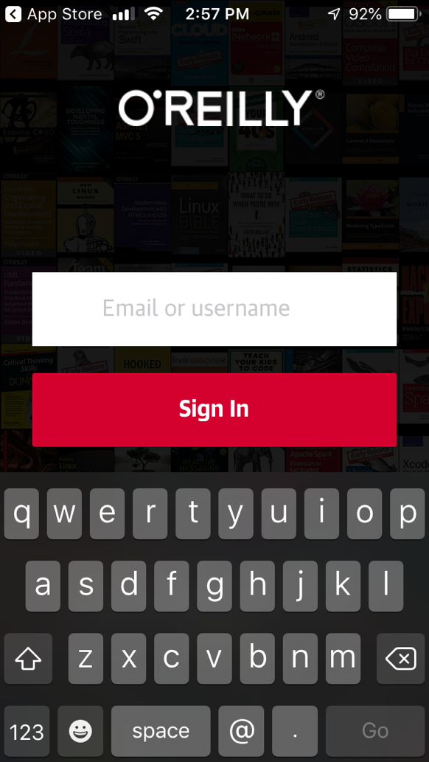

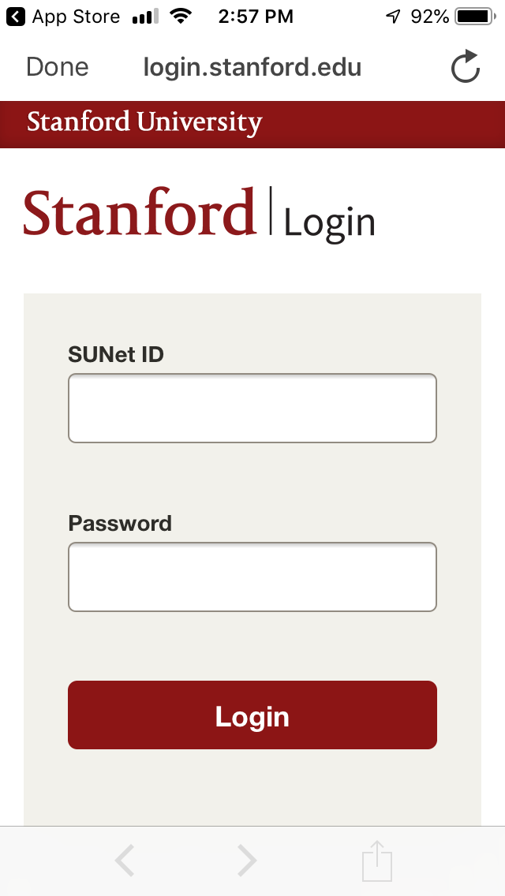

- Enter your SUNet ID and password and Login

- Use the magnifying glass icon to search by keyword, title, author, etc.

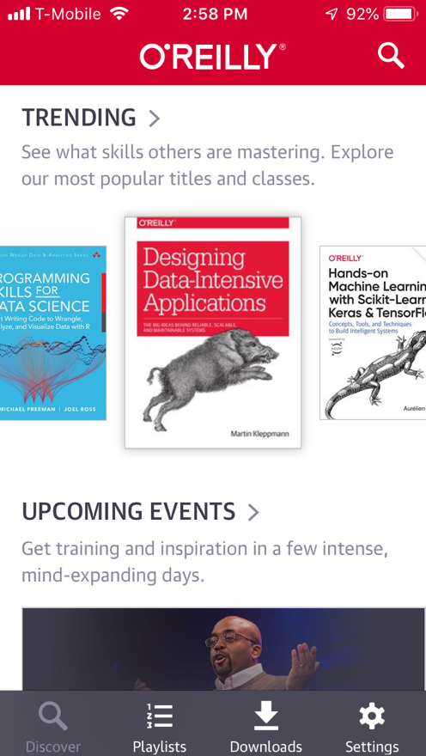

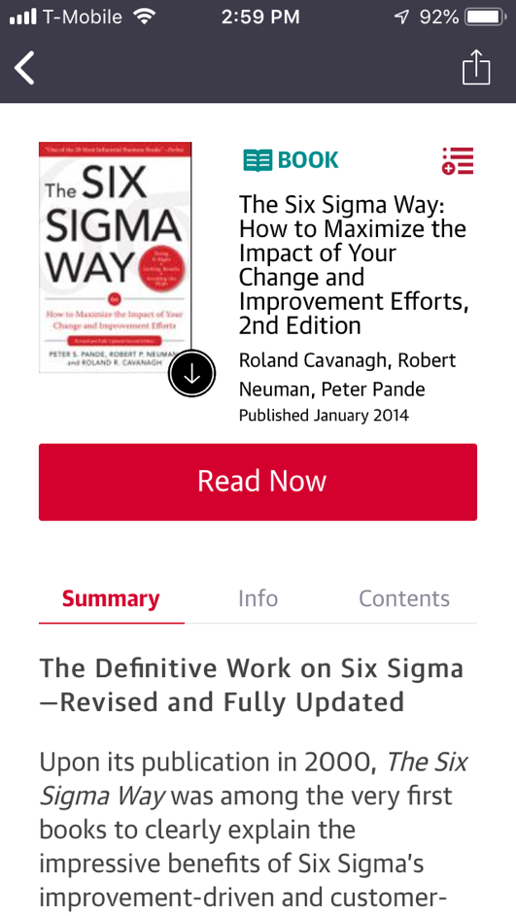
- When you select a result, you can read now or click the down arrow icon to download.

